

A framework for…

BUILDING AND PRESENTING
A
PROPOSAL FOR CHANGE

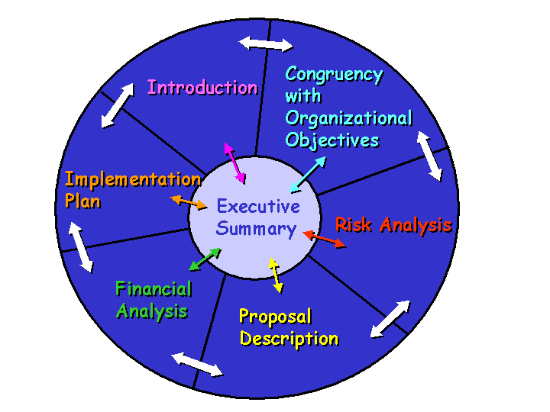

22 January 2003

A framework for…

BUILDING AND PRESENTING
A
PROPOSAL FOR CHANGE

Introduction:

When the need arises to introduce a new procedure, or practice, process, or to implement a new technology, the proposed change must be clearly communicated to many people within a large organization such as VIHA.

A communication tool is needed to introduce the change initiative, to help people prepare for the coming change, and to gain and sustain support for the change.

Proposal for Change Workbook

Although there is no single format for communicating a change initiative there are a number of key sections that should be included in a Proposal for Change, these sections include:

- Executive Summary
- Introduction
- Congruency with Organizational Objectives
- Risk Analysis
- Detailed Description
- Financial Analysis
- Implementation Plan

Details to be included within each section are described in the sections that follow.

- Executive Summary
Purpose:

An Executive Summary presents the whole story in a page or two.

This section helps communicate the proposal ideas quickly.
In this section:
- Do this section last!
- Briefly describe the proposal
- Is this new or a change to practice/service?
(If a change - include an overview of the practice/service to date)
- Briefly summarize the practice/service to date
- Briefly describe who is involved
- Briefly describe what is being asked for (e.g.: a decision, resources (money), expected change in practice behaviour)

Notes:


- Introduction to the Proposal

The Introduction should be succinct and include the following:
- Describe the scope of the problem/issue and how it was identified
- Describe the desired outcome of the plan.
- Describe how the document is organized, and at what level of detail

Notes:

- Congruency

The congruency between the proposal goals and the organizational objectives are described in this section. How does this proposal support the goals of the organization?
- Being customer focused and making the customer needs fit the priority
- Sharing expertise by working in teams
- Solutions are evidenced based
- Development of leaders at all levels
- Supporting continuous improvement

Notes:

4. Risk Analysis
While not all risk can be eliminated entirely, it is important to deliberately consider what risks may exist and what options may be available to mitigate those risks. In fact, the organization may be willing to assume a certain level of risk in order to take advantage of an opportunity, such as an improvement to service, if the risk has been carefully considered.
risk

1. the chance of something happening that could adversely impact the organization from achieving its objectives.
Failure to identify and consider a risk may actually increase the risk of harm to the organization and its programs.

What is the probability (chance) of the risk?

Risks to consider include:
    - Political
    - Economic –human resources
    - Social
    - Technological
    - Environmental
    - Legal
Some risk strategies to consider include: avoidance, mitigation, acceptance, and risk transfer

Notes:


- Proposal Description

Describe the proposal fully in this section. Consider the reader to be unfamiliar with the environment, the persons involved, or the procedures followed.
goal

- a statement describing a broad or abstract intent, state or condition that reflects an outcome.

objective

- specific performances, outcomes or behaviors related to the goal, an objective describes the intended result of a particular action.

This section should:
- Describe the goals and objectives of the change initiative
(Are the objectives specific, measurable, agreed to, realistic and time based?)
- Describe the target group
- Provide an estimate of the service over the first 3 to 5 years of operation
- Describe the stakeholder group who will be involved with the implementation and the support available for this group

The proposal description also needs to include supporting evidence. There are multiple kinds of evidence sources to use - external, internal and other:

EXTERNAL SOURCES of EVIDENCE:
- Research evidence – Research studies - both qualitative and quantitative - about the issue of concern.
- Expert opinion – What those persons “in the field” believe or practice. Opinions from other relevant sources (e.g.: academics and representatives of regulatory and professional associations) can also be ‘expert’ sources of evidence. Expert opinion may be from external or internal sources.
- Legislation
- Standards - e.g. AIM standards, Data standards, regulatory or professional standards
- Theory
- Clinical Practice Guidelines, Protocols, Policies
- Client preference – What do we know about the expressed priorities, needs, wishes of clients? Answers may be found in client surveys, patient complaints/compliments, focus groups, interviews, etc. “Clients” also includes the members of interfacing programs/teams. Evidence may be found in team meeting minutes, focus groups, and interviews. Client preference may be from external or internal sources.

INTERNAL SOURCES of EVIDENCE:
- Philosophy of Care
- Mission/vision
- Contextual experience/opinion of individual professional(s)
- Documentation
- Clinical Practice Guidelines, Protocols, Policies

OTHER SOURCES of EVIDENCE:
- Practice Committees and Councils
- Task Groups
- Peer to peer methodology and tools
Notes:


6. Financial Analysis

This section may include financial statements such as balance sheets, profit and loss statements, cash flow projections, volume projections etc. Include a breakdown of the cost of all areas of the proposal (planning, implementation, communication, etc.). The expertise and counsel of financial specialists can be consulted in the preparation of the financial analysis. The Financial Analysis should:

- Describe the capital costs – initially and over the next 3 to 5 years: what is the source and type of funding required
- Describe the ongoing operational costs - initially (training?) and ongoing
- Will the proposal generate revenue?

Notes:


7. Implementation Plan

Implementation considerations include a clear identification of accountability. Specifically describe the key leaders and their roles and responsibilities for the implementation of this plan. Implementation planning also includes a communications plan and an evaluation plan. Implementation planning includes:
transparency

- objectives and plans are presented in an open and frank manner, not excluding any persons or groups that would have a vested interest in the proposal and particulars of the project, issue or concern

- Consideration of the timelines for implementation
- How will the plan be made transparent?
- How and when will the plan be reported back?
- What will the approach to make changes to the plan?
- How will the plan/project be evaluated? Describe the mechanisms, the tools, the timelines and reporting structure.

Notes:

